NST2060 Assignment 2

Question 1
- Heterozygosity is given by the proportion of heterozygous individuals in the population. In this case, we can understand proportion as probability. Since individuals are either heterozygous or homozygous, probability (proportion) of an individual being heterozygous is simply given by 1 - probability that the individual is homozygous. p², q² and r² is simply the probability that an individual is homozygous with the allele M, N and O respectively. Therefore, the sum of them would give the total probability that the individual is homozygous. Using the formula, we get the following:
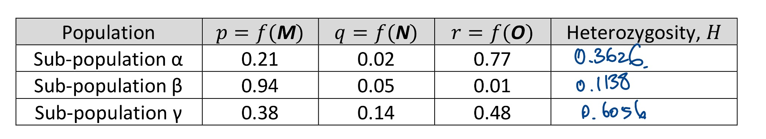

- We can use the formula that F_{st} = (H_{T} - H_{S})/H_{T} to solve this question. H_{T} is the heterozygosity of the whole population, and H_{A} is the average heterozygosity across all the sub-populations. The working is as follows:
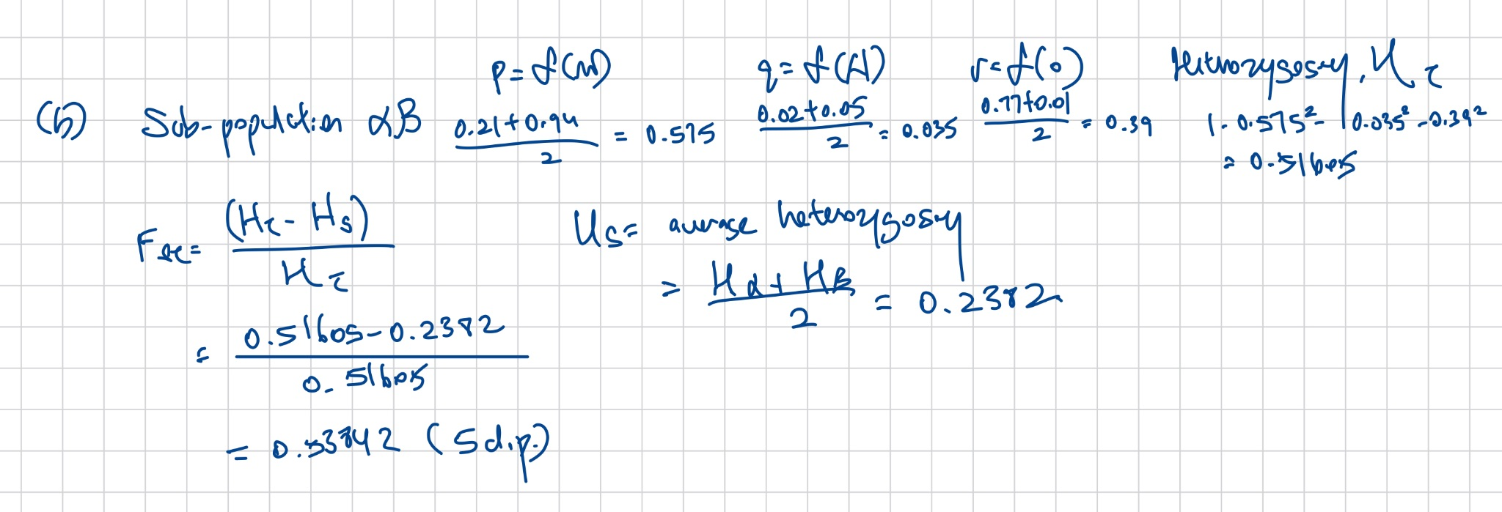
- We can see that the F_{ST} value for population ay is significantly lower than that of population By, whereas population aB has the highest F_{ST} value. The higher the F_{ST} value, the higher the extent of genetic differentiation within that population the more distinct the subpopulations are within the total population. Zooming into the allele frequencies across all three groups, qualitatively, one notice taht subpopulation a and B are the most distinct: B has the highest frequency of the M allele whereas a has the lowest, but A has the highest O allele frequency and yet B has the lowest. On the other hand, a and y are the least distinct, both of which has the highest O allele frequency within their subpopulation, and the second highest frequency as the p allele.
- The F_{ST} value for population aBy is given by 0.47821 (working is shown below). The F_{ST} value drops when population y is added to population aB. The reason for this observation is to notice that population y is somewhat in between population a and B. Population a and B are both more closely related to y than to each other, thus population y has sort of bridged the gap between the two subpopulations. Another way to phrase this is that the inclusion of subpopulation y has decreased the genetic difference between groups, thus H_{T} drops. On the other hand, since population y has a great genetic difference within the group (as evidenced from the high heterozygosity in population y), it also increased the average genetic differences within the group, thus H_{s} increases. The combined effect of this change is that (H_{T} - H_{S}) actually decreases, and it decreases by a greater extent that H_{T} alone. This eventually leads to the decrease in the F_{ST} value for the total population aBy.
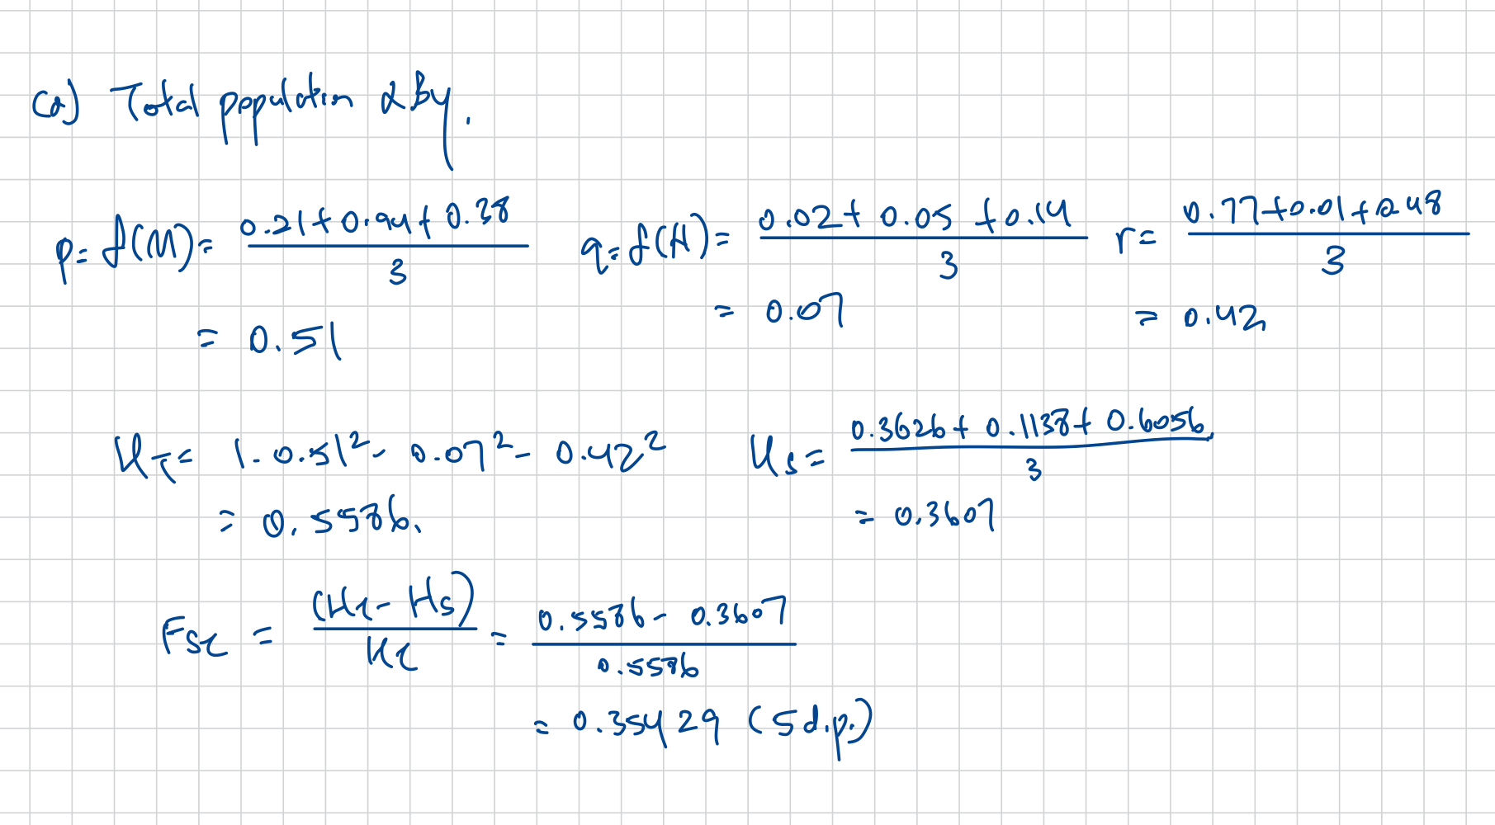
- The two possible patterns are given as follows that follow the F_{ST} values. In addition, I believe they also conform to the H values for each subpopulation. The general rule is that: Populations that are more genetically different from each other must have separated earlier, and populations with great internal genetic differences must have diverged earlier compared to those with lower internal genetic differences. (But I really can’t think of a third pattern consisting of only one-way migrations, even if I disregard the individual H values).
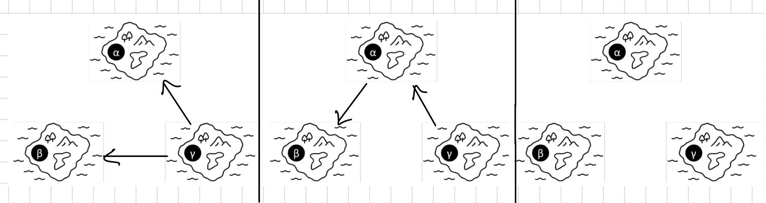
- A total population with a higher F_{ST} value has two general characteristics: One is that they have great genetic differences between groups. The second is that within each group, there are low genetic differences observed. Therefore, migration pattern 2 better fulfils those two conditions. Firstly, the genetic difference between groups is likely to be high because each island, imposing a unique set of conditions and hence selective pressure, would lead to natural selection for and against certain alleles. This makes the current population more genetically different from their group that they migrated out from. Then when another group migrates out of it, the process repeats, further increasing the genetic differences across the migrating populations. This is contrasted against pattern 1 where each migrating population still shares the same ancestral population, thus maintaining a baseline genetic similarity between the populations. This process then repeats for each successive migration. Within each population, we'd expect a lower genetic diversity within the population on each island due to the repeated serial founder effect where each new migrating population carries a smaller set of genes from their predecessors. This again is contrasted against pattern 1 where the serial founder effect only happens in one layer, thus each migrating population would still be more genetically diverse compared to that in pattern 2.

Question 2:
- The frequency of each allele is simply the sum of the count of haplotypes that they are a part of. A: 299, B: 284, C: 307.
- On this end, linkage disequilibrium at locus 1 and 2, D_{AB}, is given by the difference between the observed haplotype frequency and expected haplotype frequency of AB: f(AB) - f(A)f(B). The same can be done for D_{BC} and D_{AC}. We can derive the haplotype frequency of each haplotype by again summing up the frequency of haplotypes that consists of the haplotype that we are interested in. The total count is given by: 500. f(AB) = 170/500 = 0.34, f(BC) = 114/500 = 0.228, f(AC) = 206/500 = 0.412, f(A) = 299/500 = 0.598, f(B) = 284/500 = 0.568, f(C) = 0.614. With all this information, we get that D_{AB} = f(AB) - f(A)f(B) = 0.34 - 0.598(0.568) = 0.000336. We do the same for BC and AC to get D_{BC} = -0.120752, D_{AC} = 0.20324
- Using the formula that r² = D² / (f(A)f(a)f(B)f(b), where A/a and B/b are alleles at the two loci that we are comparing, each of the term we can obtain via a similar construction shown in part (b). We find that r²_{AB} = D_{AB}²/f(A)f(b)f(B)f(b)= 0.000001914, r²_{BC} = D_{BC}²/f(B)f(b)f(C)f(c) = 0.023857, r²_{AC} = D_{AC}²/f(A)f(a)f(C)f(c) = 0.273490.
- The greater the linkage disequilibrium (greater r² value), the closer the two loci are because the less likely they will undergo independent assortment. That is to say, the crossing over has less than a 50/50 chance of separating them, leading to greater linkage between them. The diagram is shown below with accompanying explanations on the relative distances between the three loci:
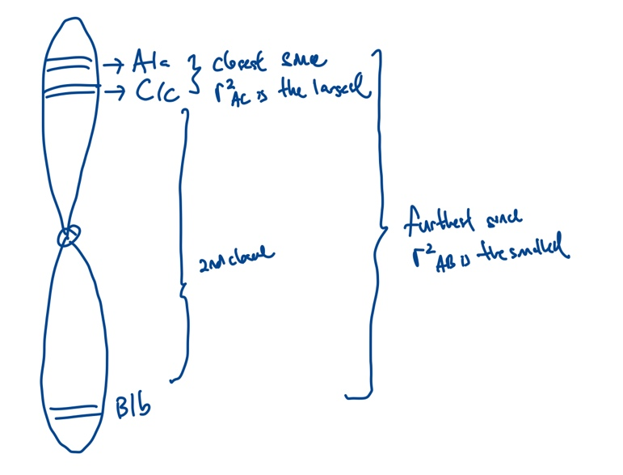

- Based on the National Wildlife Federation, the typical modern day grey wolf weighs around 32 - 65 kg for males, and 27 - 45 kg for females. (National Wildlife Federation, 2025). In essence, the extinct wolf lineage, which shares morphological similarities with the modern-day grey wolf is likely to be of a giant breed. Given this, group 2 is likely to be the small breed for the following reasons: To get a small breed from the ancestral giant breed, some mutations about the IGF1 must have been strongly selected for through selective breeding. Therefore, we’d expect the SNPs that occurred at/near the IGF1 to be strongly preserved with low heterozygosity, since they are essentially either the mutations that were responsible for the smaller body size that the breeders were selecting for until they reached fixation (zero heterozygosity), or they could have been the genetic hitchhikers that were brought along since they were close to the desirable SNPs that led to smaller body size. For Group 2, notice that the SNPs that are positionally proximate to the IGF1 have a near-zero H_{obs}, that means there has been a selective sweep for the SNPs that occurred near the IGF1, which is a strong evidence suggesting that selective breeding has occurred for group 2 for individuals of smaller body size. For group 1, we notice that the SNPs occurring near the IGF1 do not exhibit low H_{obs}. It means that normal variations happened instead, allowing them to preserve the giant size of their ancestors.
- Referencing the diagram attached below, we’d expect a horizontal straight line (drawn in red) to be the disequilibrium pattern around the IGF1 locus with no peaks. Unlike the smaller breeds where r² is close to 1 for positions near the IGF1 due to genetic sweep, larger breeds of dogs will not experience selective pressure for SNPs near the IGF1 gene. Therefore, we’d expect a similar value of r² across different positions on the chromosome. It is also non-zero, because in practice SNPs that are closer to each other are unlikely to experience independent assortment due to their proximity leading to < 0.5 probability that they are separated during crossing over. Therefore the red line is drawn on some value of r² > 0.
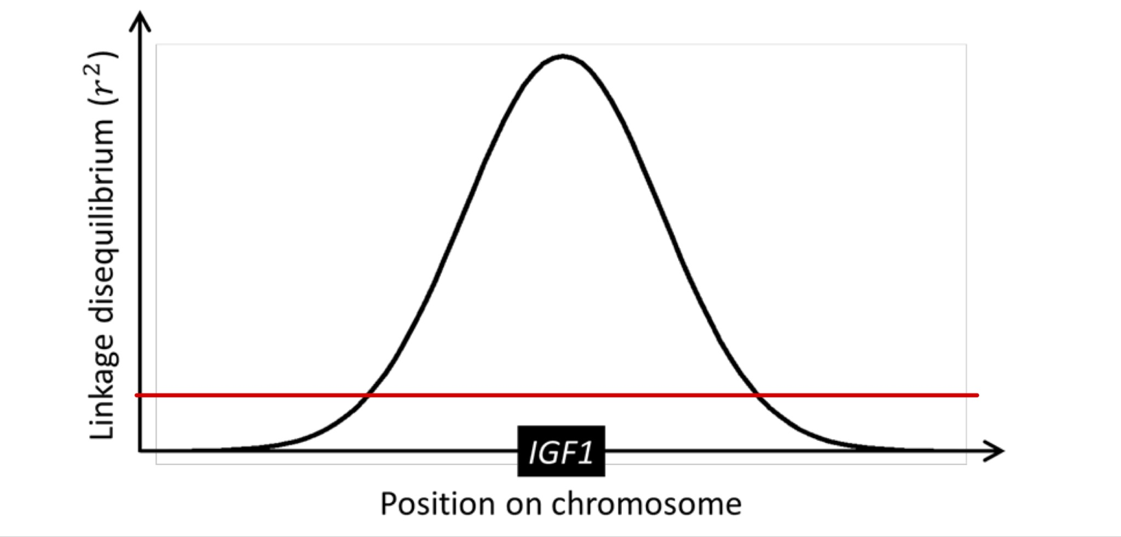

Question 3
- To obtain the midparent phenotypic value for both traits, we take the average of average (where the latter average refers to the average value of the parent). Using this construction, midparent phenotypic value for the first trait = , second trait = .
- The two plotted graphs are shown below:
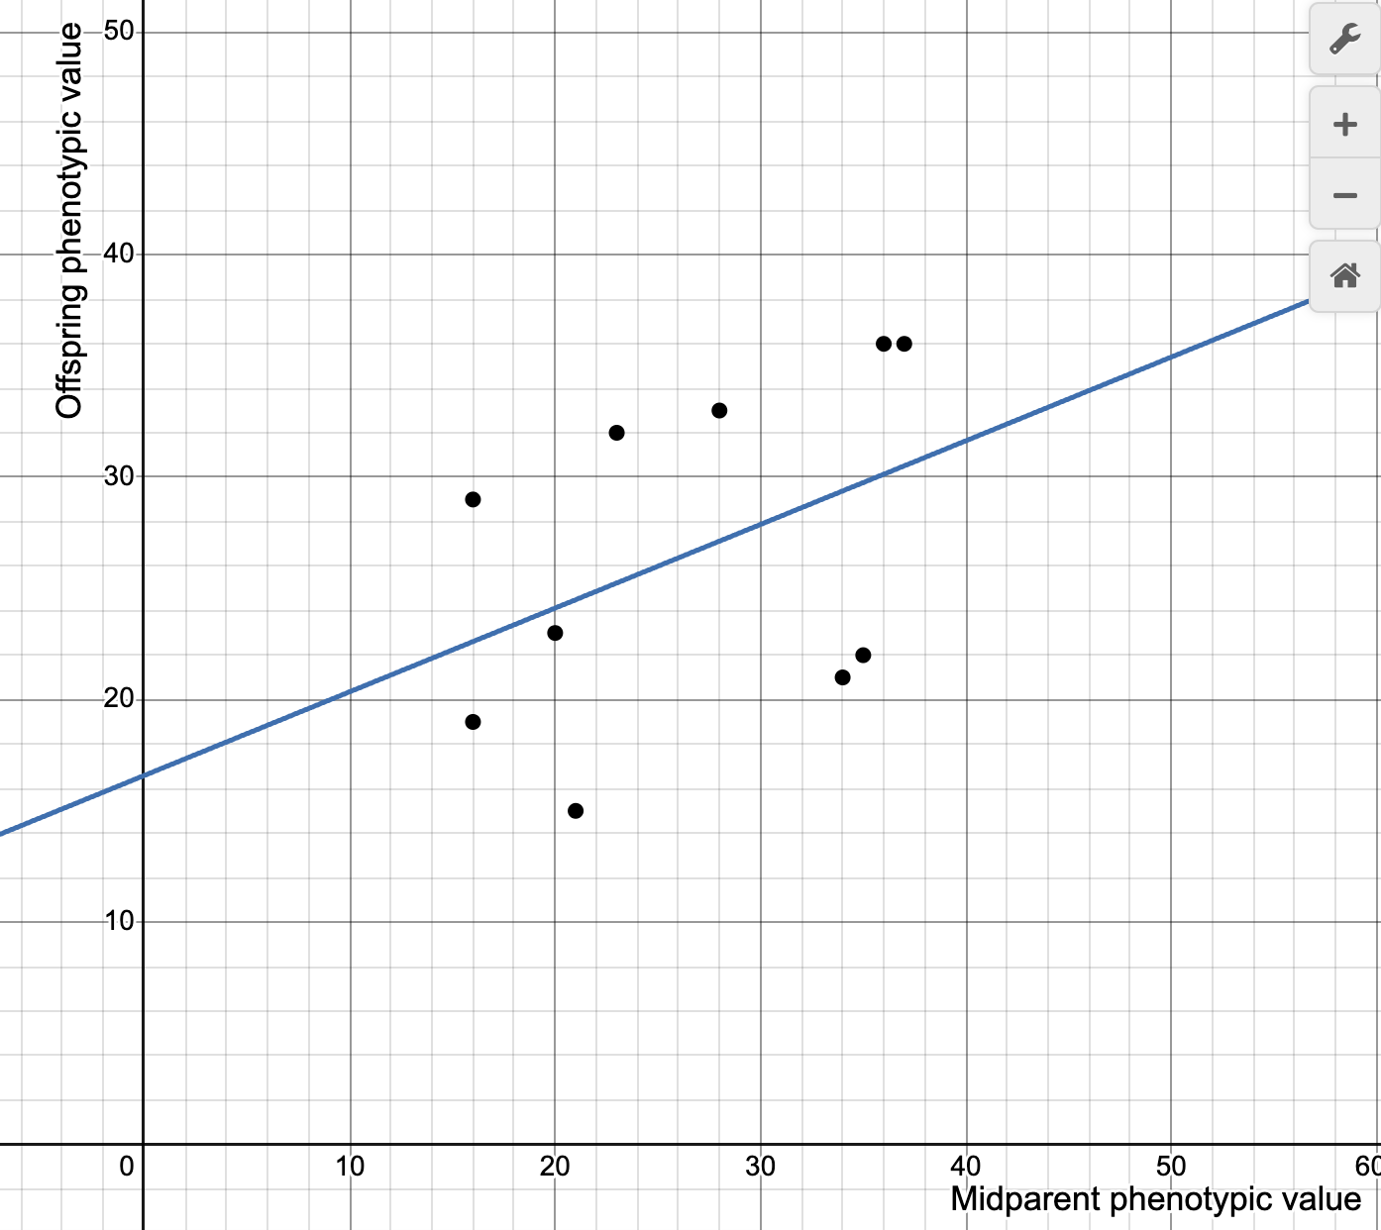
^For Trait 1

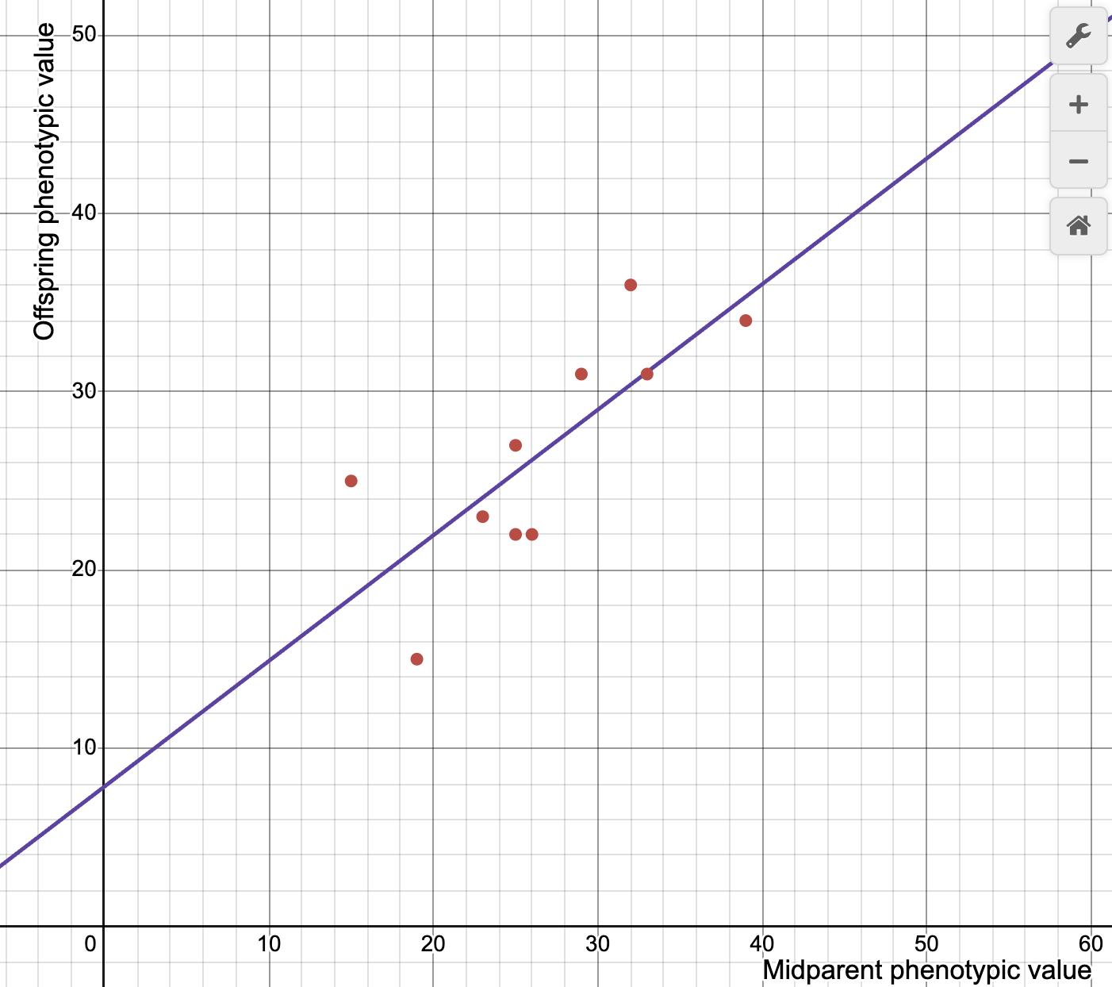
^For Trait 2
- Based on the graph constructed, the gradient has special significance: The closer the gradient is to 1, the higher the heritability of this trait (the parents’ phenotypic value prefect predicts the phenotypic value of the offspring). Any deviations from that would then mean a lower heritability. Since the graph for trait 2 has a gradient that is closer to 1, trait 2 has a greater heritability.
- This new allele would decrease heritability of the trait. The reason for that is that, while the trait was introduced to all the offspring, it was not introduced to any of the parents. In other words, it does not add to the parental genetic additive variance V_{A} but decreases it instead. Moreover, since this addition of 10 is conditional, we can intuitively understand it as some external environmental force that alters the phenotypic values of the offspring, therefore increasing the environmental genetic additive variance V_{E}. Since h² is positively correlated with V_{A}, the drop in V_{A} would lead to a corresponding drop in h².
- The idea behind is, in some areas the environmental factor would lead to greater change, and in others, it would be the genes instead. The heritability of the oxygen-carrying efficiency is the highest for the highland Tibetan population. Since the whole population virtually lives in the same environment, we’d expect environmental variations within the population to be small, therefore any phenotypic variation, that of the oxygen-carrying efficiency can be attributed largely to genetic variation. The second one would be the regional population consisting of the Tibetan and Hans Chinese exclusively. It was known that both populations had different oxygen carrying efficiency levels due to recent natural selection. Therefore, the passing of these different alleles would then grant their offspring different levels of oxygen carrying efficiency. In other words, the phenotypic variance that we observe, is still likely due to genetics. The last would be the global population since there are so many different environments exerting different selective pressures for varying levels of oxygen carrying efficiency. In that case, environmental factors would be playing a larger role in influencing the phenotypic values that are observed compared to the previous 2 cases where the environmental conditions were largely the same for the population in question.

Question 4
- The populations found are as follows: Zuphu, Vanka, Ximbili, Yodoro and Weese. The count of each population is given by (in the same order): 30, 32, 32, 27, 29.
- The plots and their corresponding explanation is shown below:
  - For K = 2:
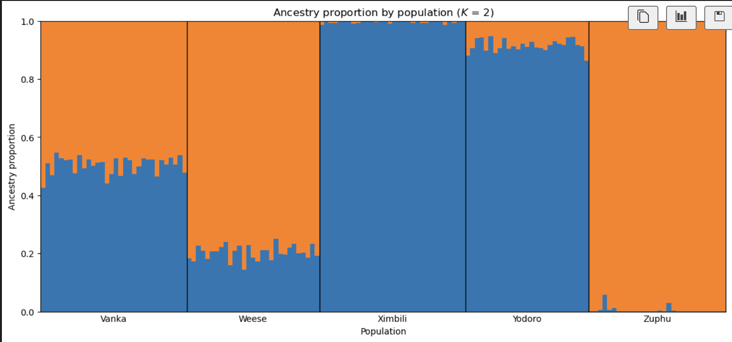
Individuals in the Vanka population have an almost equal split of blue and orange ancestry. Individuals of the Weese population are of majority orange ancestry. Individuals of the Ximbili population are almost exclusively of blue ancestry, with a trace of orange ancestry. Individuals of the Yodoro population are of majority blue ancestry. Individuals of the Zuphu population are almost exclusively of the orange ancestry, with a trace of blue ancestry.

  - For K = 3:
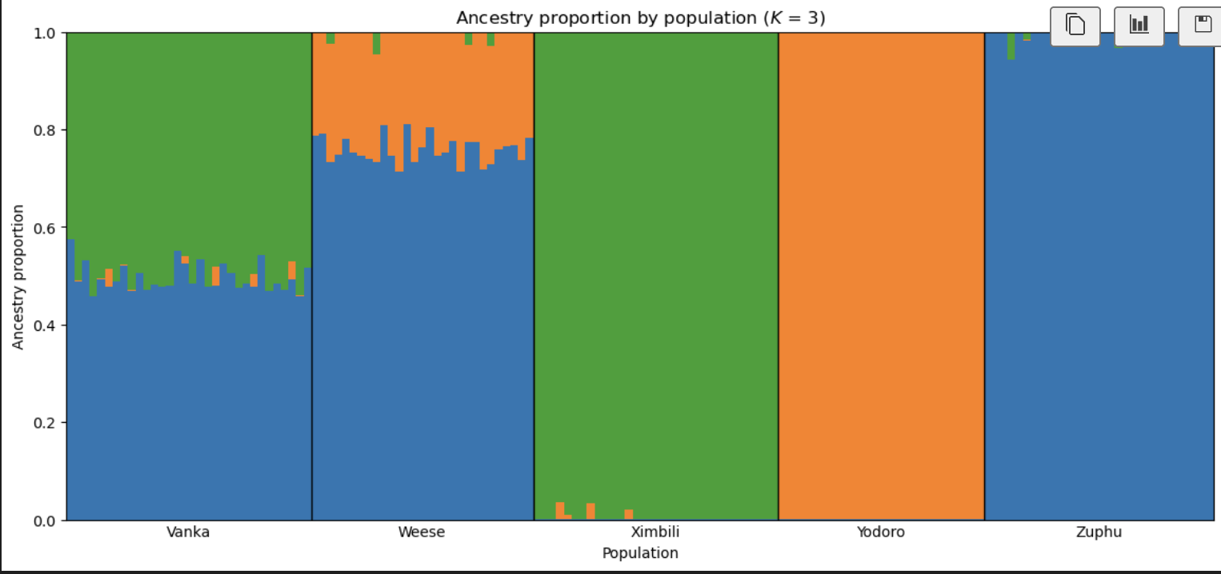
Individuals of the Vanka population have a near equal split of green and blue ancestry, along with a trace of orange ancestry. Individuals of the Weese population are of majority blue ancestry, followed by orange ancestry and then a trace of green ancestry. Individuals of the Ximbili population have almost exclusive green ancestry with a trace of orange ancestry. Individuals in the Yodoro population are of complete orange ancestry. Individuals of the Zuphu are almost exclusively of the blue ancestry, with a trace of green ancestry.

  - For K = 4:
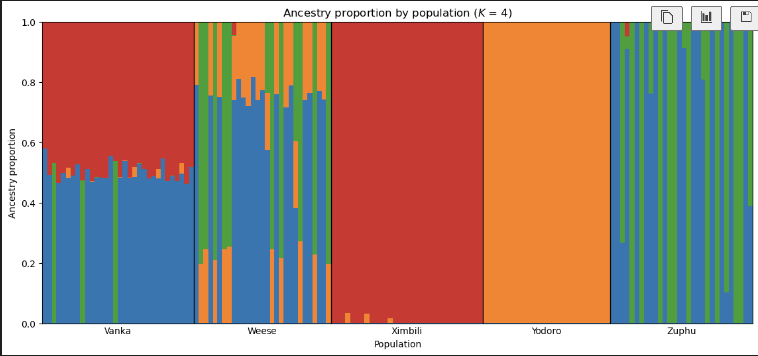
Most individuals of the Vanka population have an equal split of red and blue ancestry, with a trace of orange ancestry, whereas some have an equal split of red and green ancestry. Individuals in the Weese population have either a mix of blue and orange ancestry, or a green and orange ancestry, some also have all three. Individuals in the Ximbili population have an almost exclusive red ancestry, with a trace of orange ancestry. Individuals of the Yodoro population has a complete orange ancestry. Individuals of the Zuphu population have either a complete blue or green ancestry, or a mix of both. There are also a small number of individuals with a trace of red ancestry.

(c) Comparing all three plots, we can infer that K = 3 is the most plausible. Firstly, we compare the plot that we got for K = 3 with that of K = 2. We can clearly see that for K = 2 the ancestry is clearly oversimplified because it grouped both Ximbili and Yodoro to the same ancestry, but at K = 3 we are able to differentiate between the ancestral source between the two. Now comparing to K = 4, we see that the plot reveals certain implausible patterns characterised by the long strips of different color. Those strips suggest that there are individuals possessing a particular ancestry exclusively, and yet some other individuals possess another particular ancestry exclusively too. It is highly unlikely for individuals in the same population to not share any ancestry at all, therefore at K = 4 the individual ancestry might have gotten over-fragmented. Therefore, K = 3 is our best guess because it reveals additional ancestral sources over K = 2, and also produces more plausible outcomes than K = 4.

(d) The migration pattern further confirms that K = 3 is the most plausible value. Notice that there are three islands that were initially occupied, they correspond to the populations that are exclusively one ancestry (Ximbili, Yodoro, and Zuphu respectively) since they do not undergo admixture. On island I and V, we see that two different populations migrated on it respectively, leading to the populations having two main ancestries, corresponding to Vanka and Weese. Since both Weese and Vanka both share the “blue” ancestry, the same population must have migrated to both I and V. Therefore, the population on island IV is likely Zuphu. Since population III migrated more, it corresponds to the “green ancestry” (Ximbili) since we see that amongst the population with two main ancestries, green is the one with greater proportion, which indicates a greater extent of migration. Island II would then be “orange” (Yodoro). The population on island V is Weese (one ancestry dominates the other) and island I is Vanka (equal share of two ancestry).

The table is shown below:

Landmass | Occupying population | Ancestral population
I | Vanka | 50% Ximbali, 50% Zuphu
II | Yodoro | 80% Zuphu, 20% Yodoro
III | Ximbili | 100% Ximbili
IV | Zuphu | 100% Zuphu
V | Weese | 100% Yodoro

Question 5
- The term has the root Malay word anak [child]. Peranakan has an adjective meaning of “born of”. Today, peranakan has taken on the status of cultural identity and refers to a range of mixed heritage communities. Their unifying trait is the melding of ancestral cultures with the indigenous cultures of the Malay-Indonesian archipelago.
- The picture is shown below:
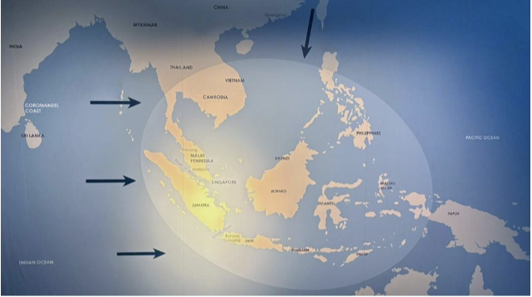
- The individuals are named as follows:
  - Lie Pa-toe Nia
  - Sharifa Binte Omar Aljunied
  - Eliza Thomazias
  - Emily Gan
- The name and function of the objects are named below:
  - Outer gates (pintu pagar): It provides ventilation, security and privacy when the front door is left open during the day. Finely carved pintu pagar served as symbols of wealth for peranakan families.
  - Armchair (hup soo ee): They are nearly always part of the formal furniture setting in the thia besar (big hall) of the traditional Peranakan house, which was used to receive guests and for special occasions like weddings and funerals.
  - Kamcheng: This container was used to store drinking water or food.
  - Star brooch (bintang): They are worn on a bride’s bodice during a wedding
- The two birds are shown below:
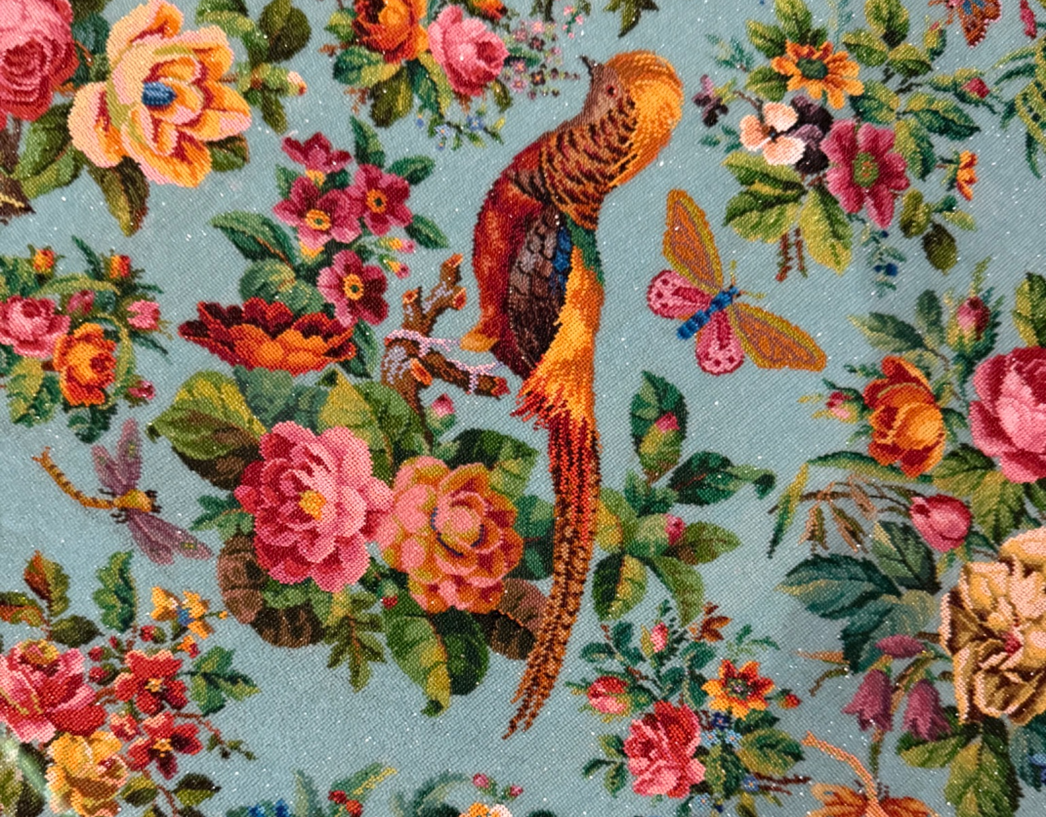
Golden Pheasant: https://ebird.org/species/golphe?continue
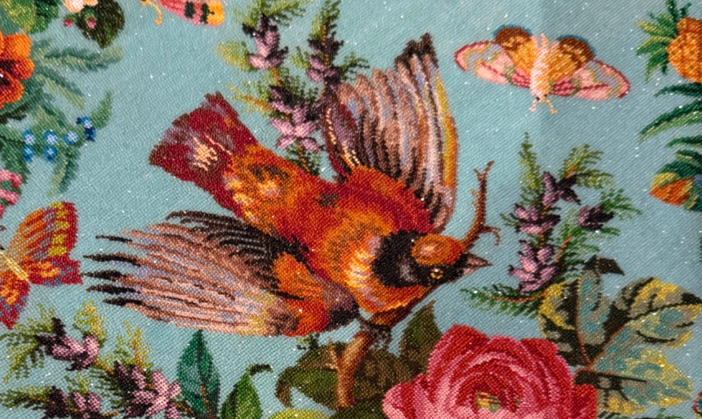
Red bishop: https://www.instagram.com/p/DQ_eoD6DIEq/
- The item that I chose is the Coffee Pot (image attached below). It exemplifies the cross-cultural influence in the peranakan community because it contains auspicious Chinese motifs, such as birds that symbolises freedom, that are favoured by the Peranakan Chinese. To make this silverware, the local Peranakan consumer could have approached the immigrant Chinese silversmiths and commissioned them to produce this pot. Moreover, since Chinese export silver is also meant for the European market, this item illustrates both the Chinese and Western influences on the lifestyles of the Peranakan community.

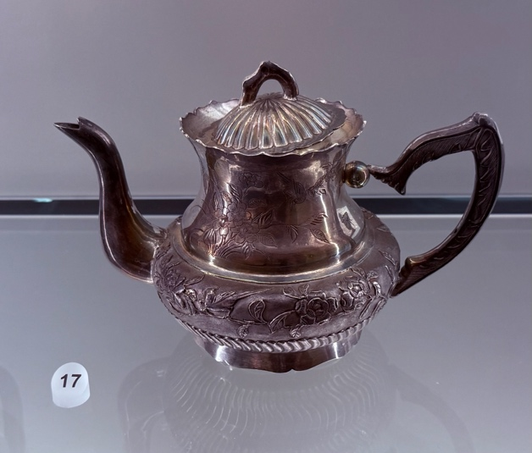

References

National Wildlife Federation. (2025). Gray Wolf. National Wildlife Federation. https://www.nwf.org/Educational-Resources/Wildlife-Guide/Mammals/Gray-Wolf

Link to LLM Chat

